Exercise 2

10/10/2020

AIM:

To count the given number present in the list

Program:

def countX(list,s,b):

c=0

for i in range (0,b):

if(list[i]==s):

c+=1

print(c)

list=[]

a=int(input())

for i in range(0,a):

list.append(int(input()))

s=int(input())

b=len(list)

countX(list,s,b)

Link:http://103.53.53.18/mod/vpl/forms/edit.php?id=230&userid=1787

Output:

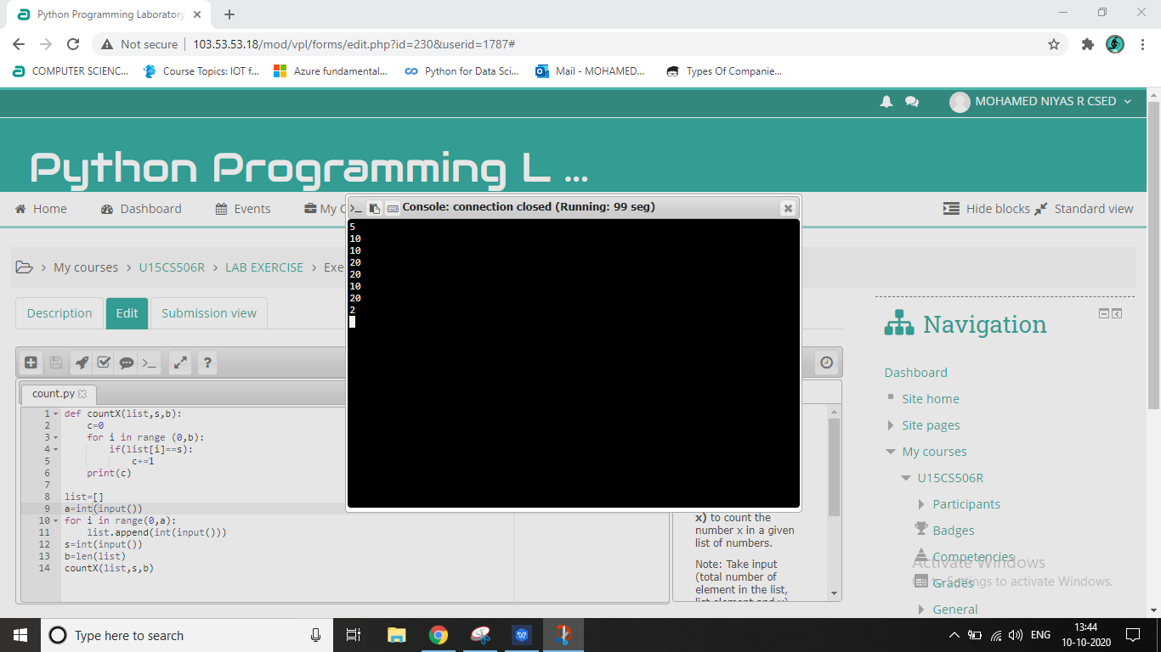

Result:

The count was calculated and printed successfully